Lab 15: Patching EXEs with Ollydbg
Course Name: Malware Analysis and Reverse Engineering (IAM302)
Student Name: Nguyễn Trần Vinh – SE160258
Instructor Name: Mai Hoàng Đỉnh
Lab Due Date: 11/3/2023

Purpose
- To practice disassembling and modifying binaries.

What You Need
- A Windows machine, real or virtual. I used a Windows Server 2008 virtual machine.
- You need several files to examine. They are all in the Documents folder of the VM your instructor handed out. If you don't have that, download them with these links:
- exe
- 3EXEs.zip
- easy.zip
- 256exes.zip

9.1: Patching an EXE (15 pts)
Getting the EXE

Checking the Hash
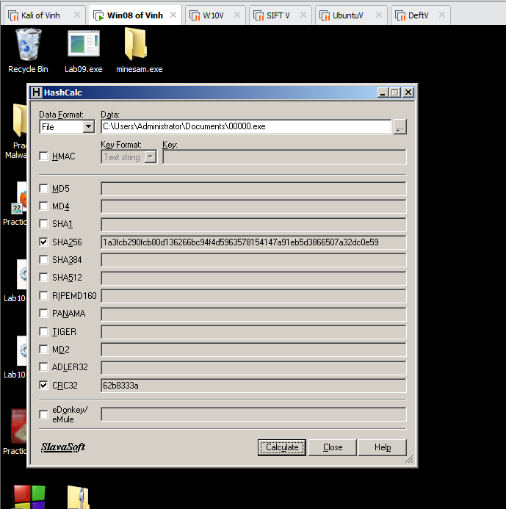

Running the EXE
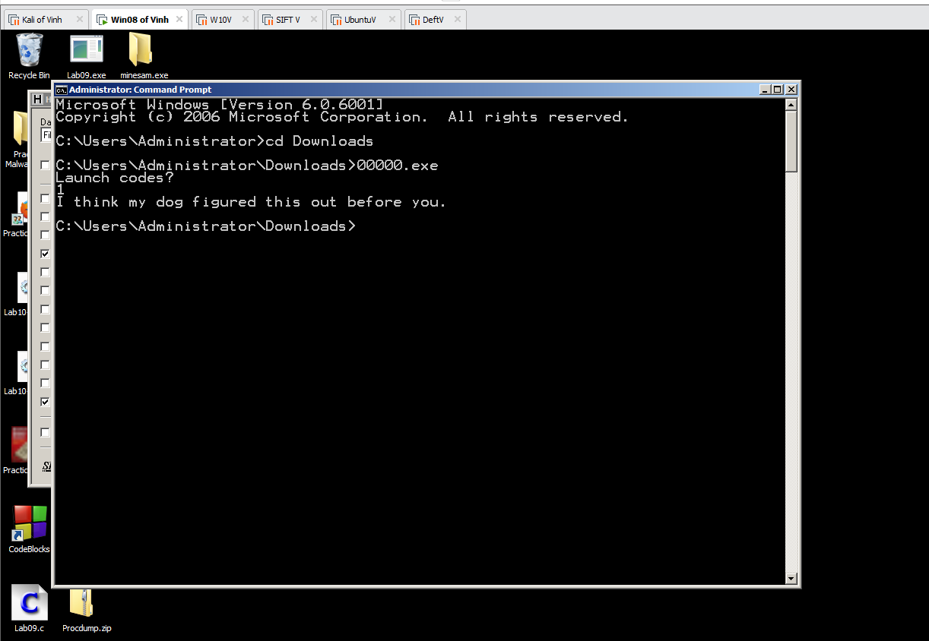

Examining the EXE with Ollydbg
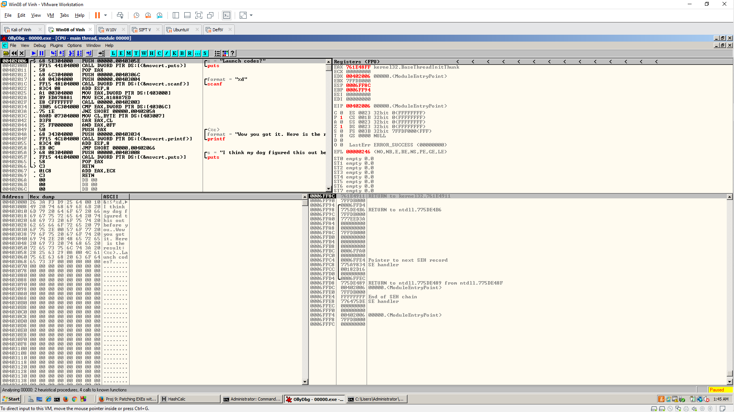

Modifying the EXE
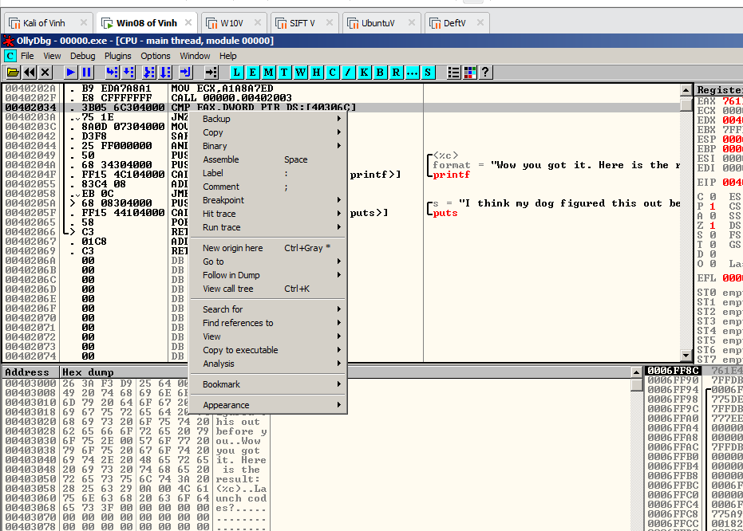
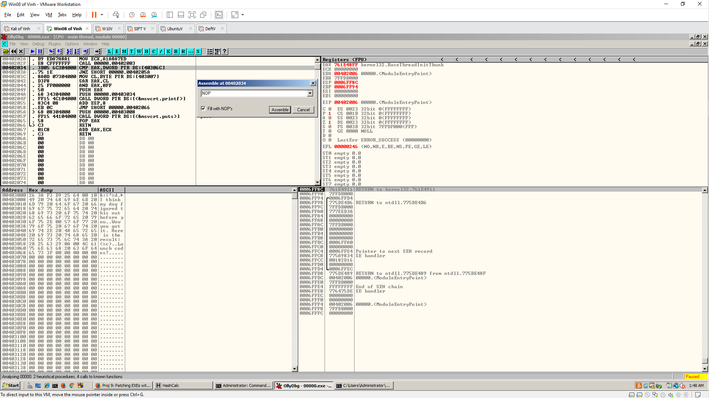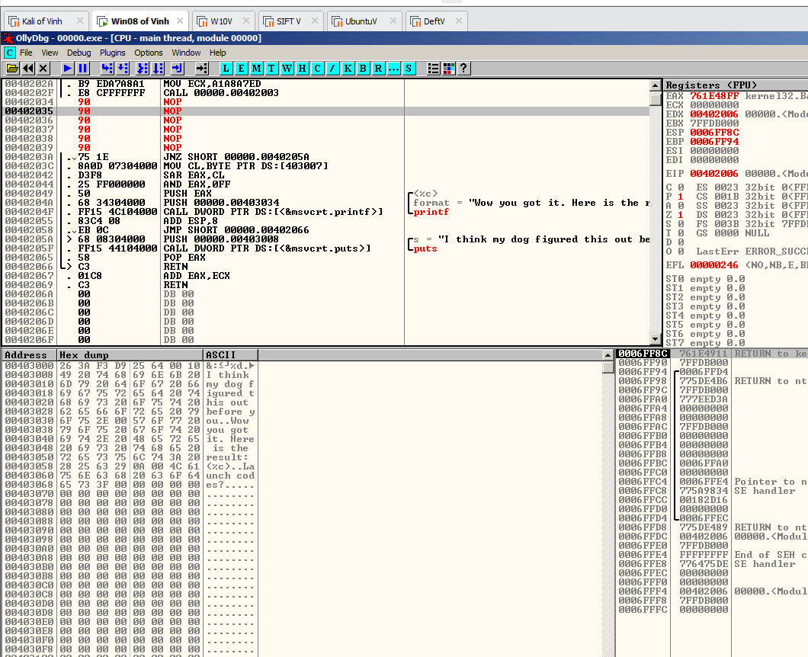
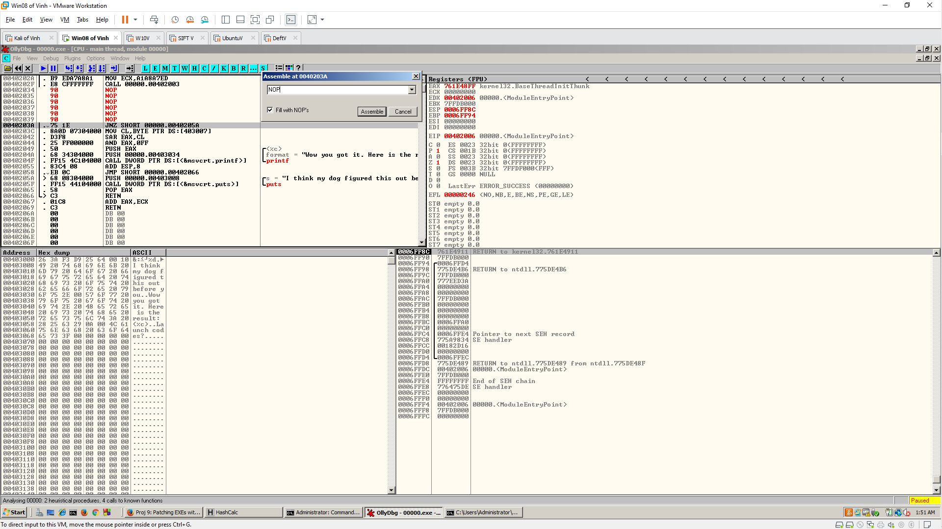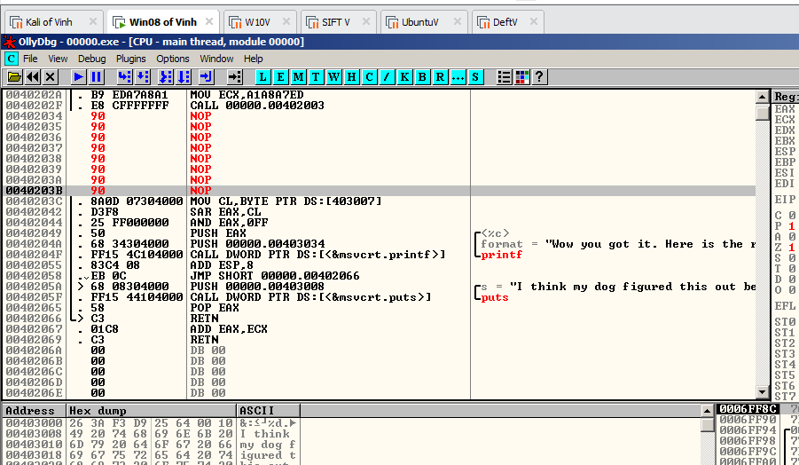

Saving the Modified File
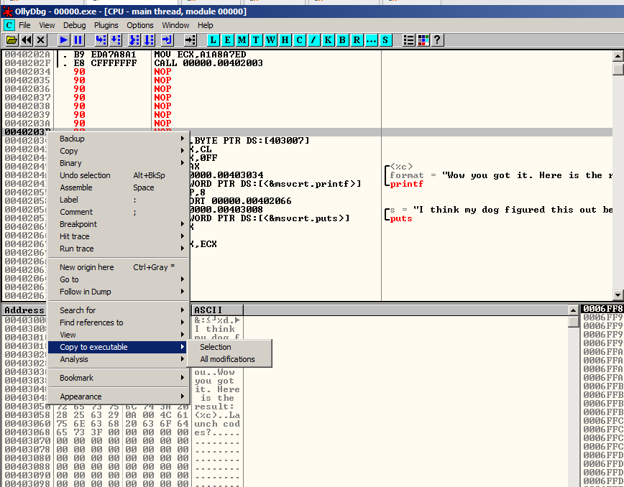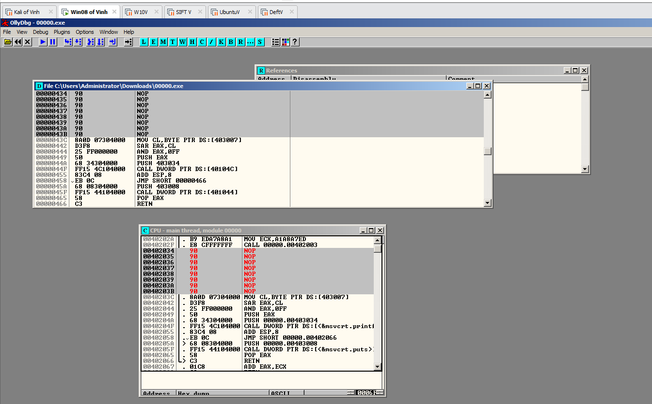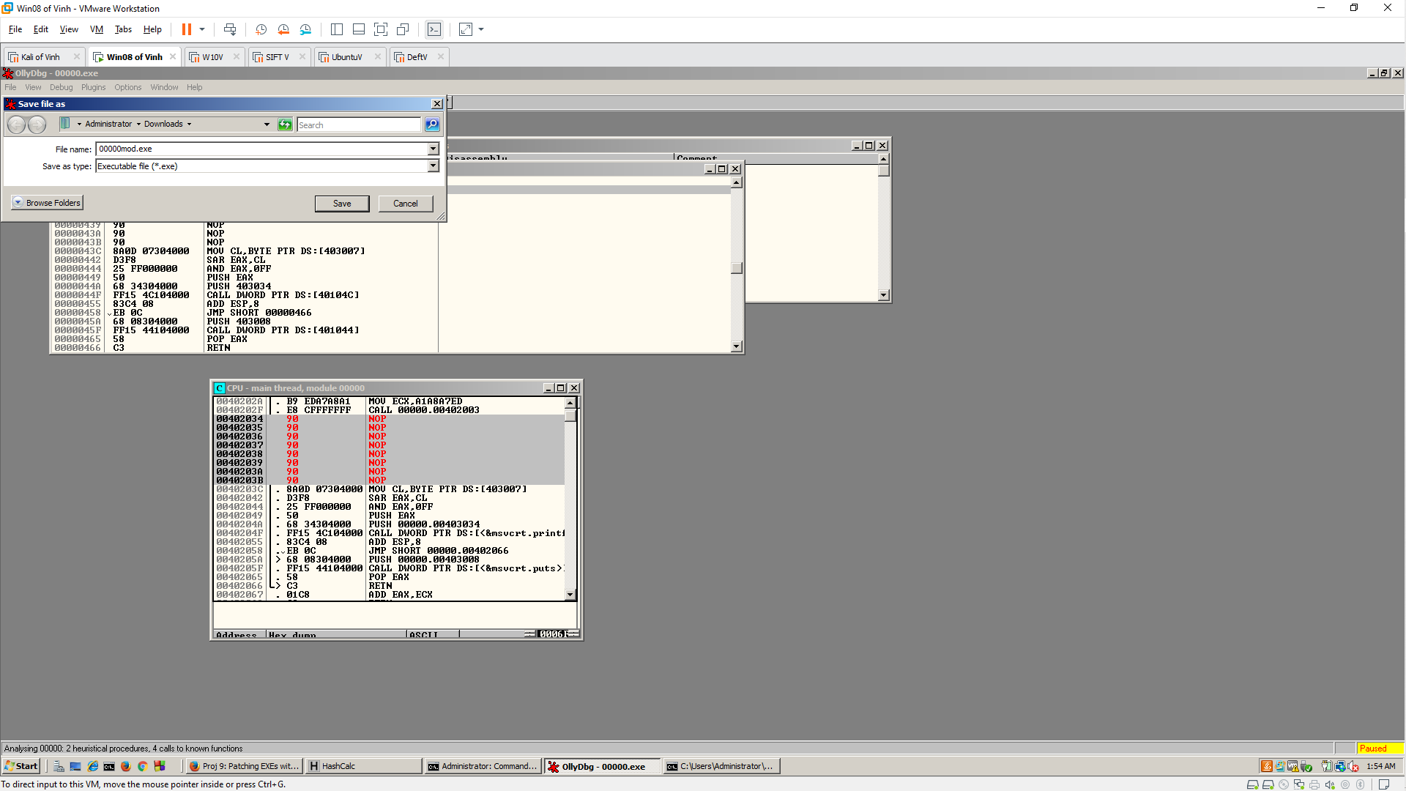

Running the Modified File
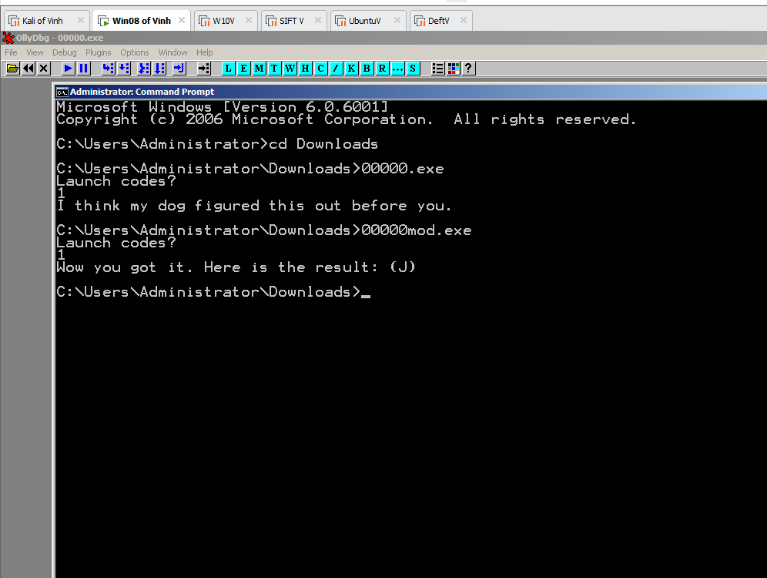

Checking the Hash
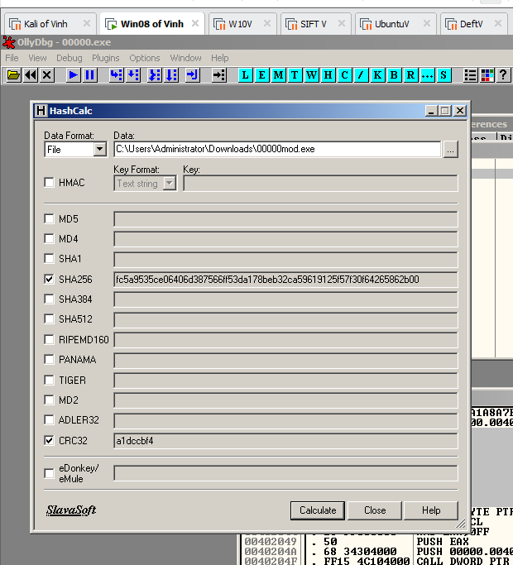

9.2: Patching Three EXEs
Getting the EXEs

Checking the Hash
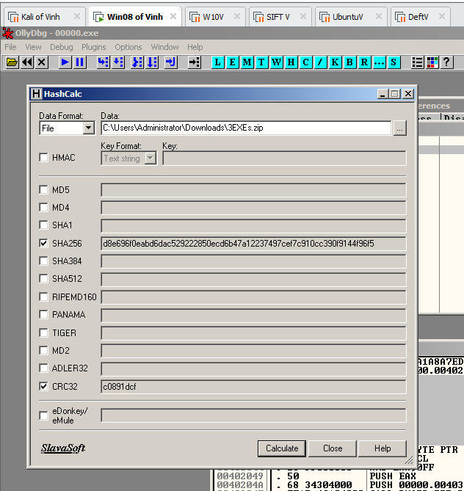

Patch the Files

00000.exe
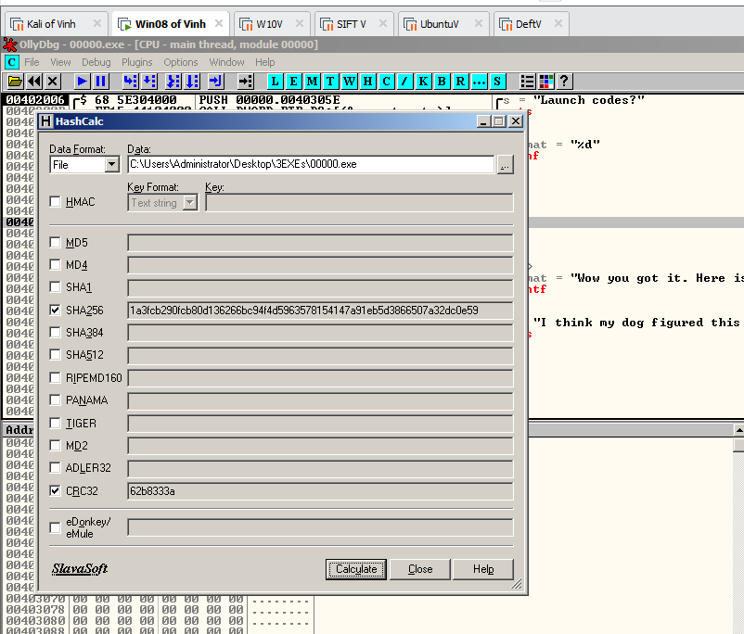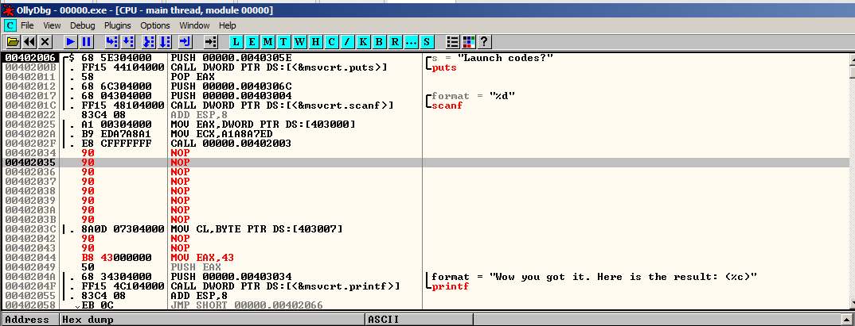

0000a.exe
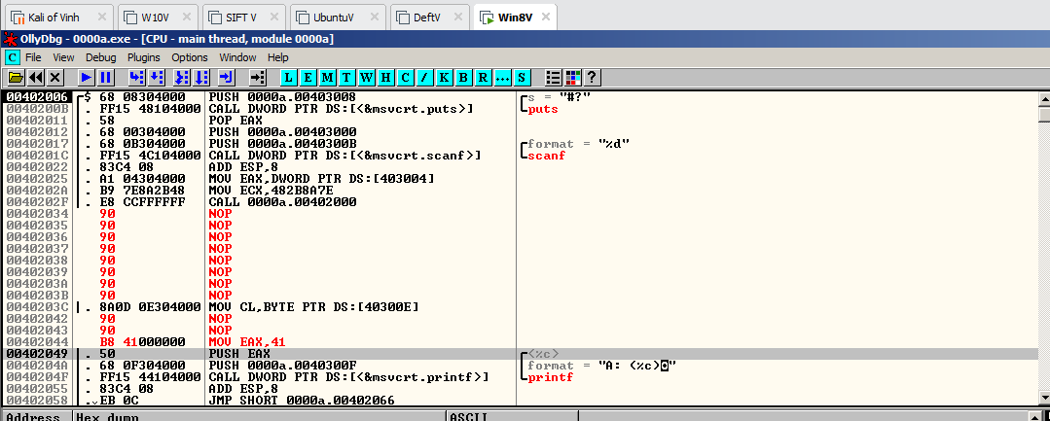

000a1.exe
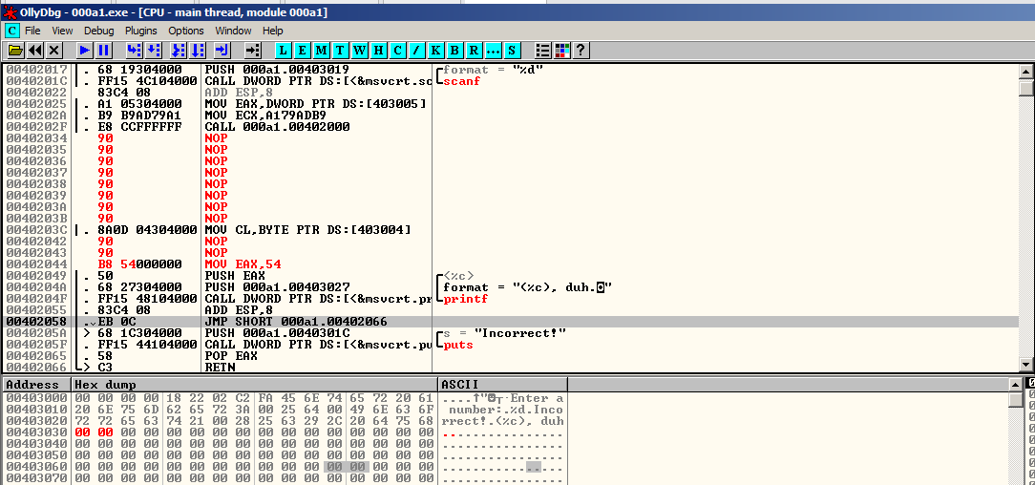

Run file
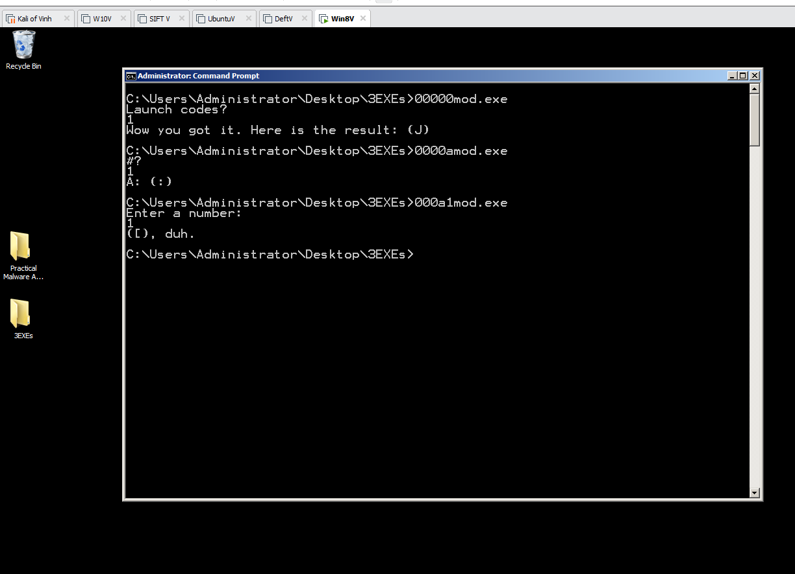
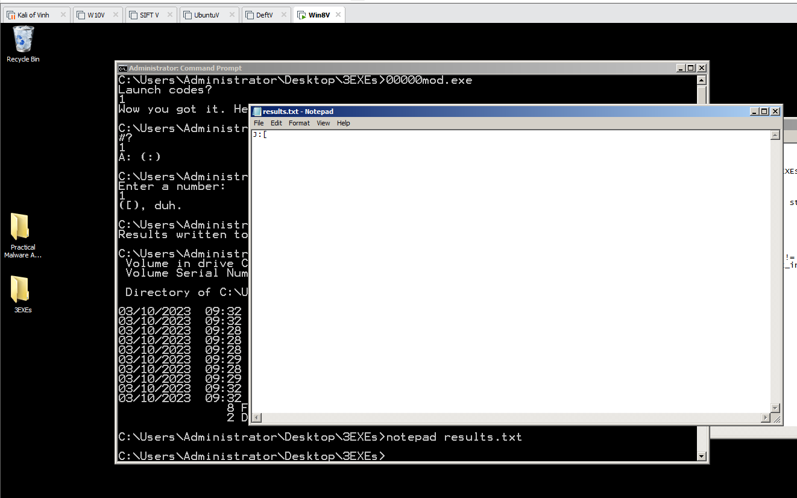

9.3: Patching 19 EXEs
Making Python Run on Windows
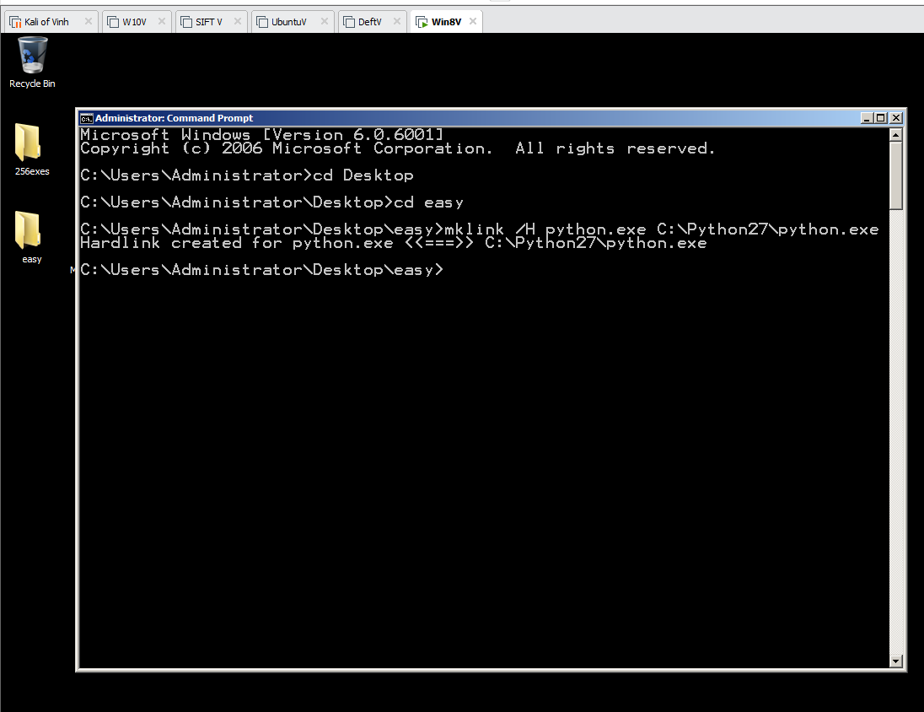

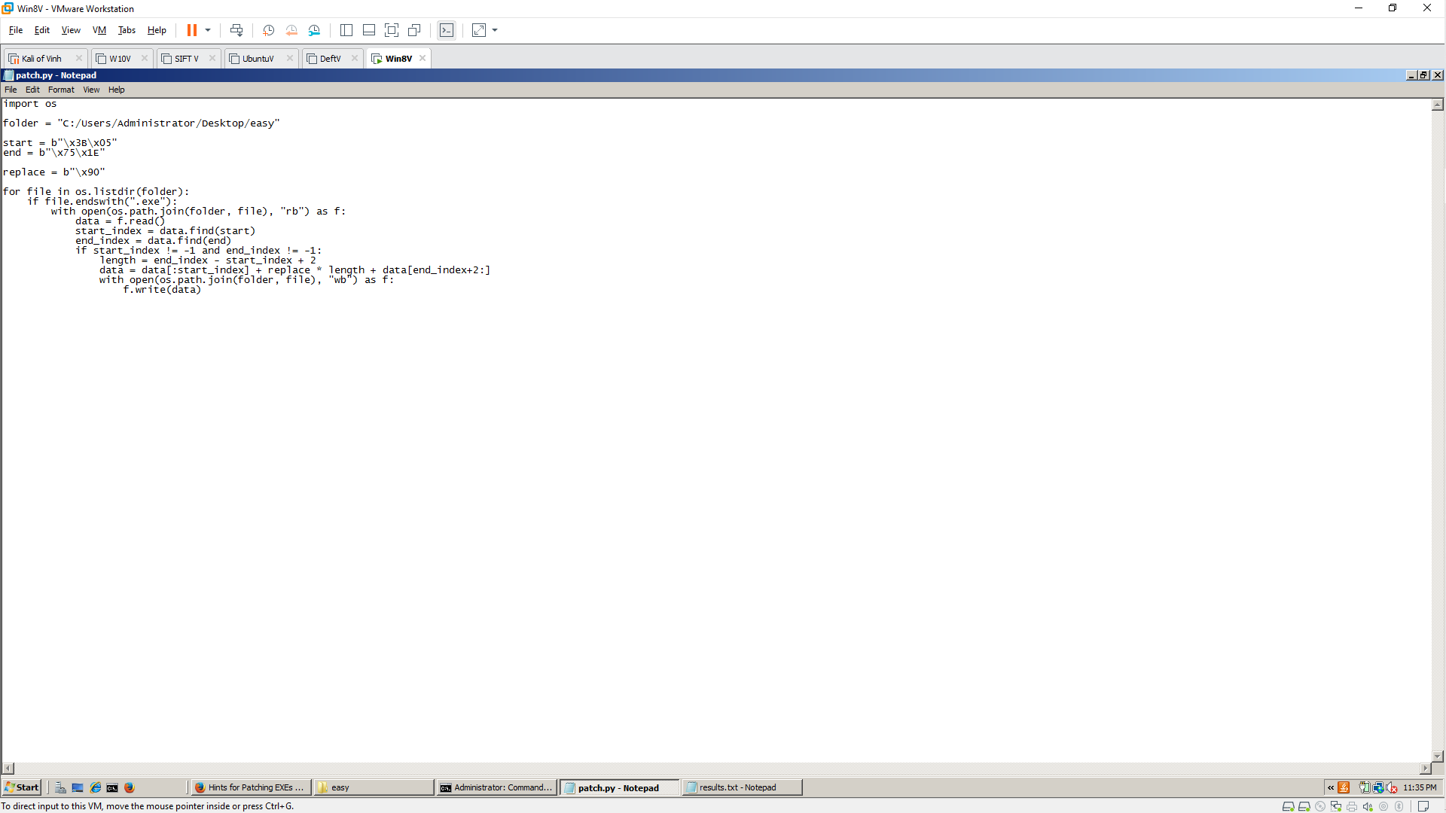
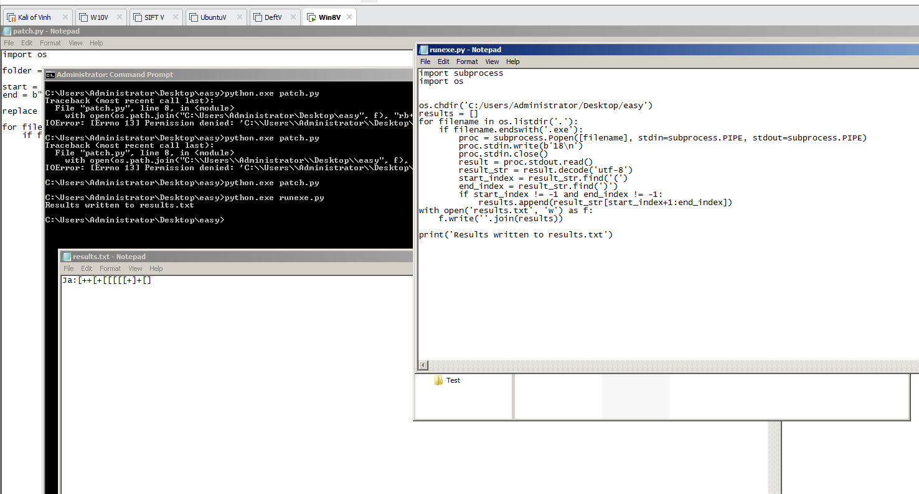

256exes
